# Purchase Response

Version: 1.5

**Change History**

| Version | Changes Summary | Author |
| --- | --- | --- |
| 0.4 | Corrected CreditCard subsection so it now states that the user’s credit card is always charged for the purchase each time the user sends a YES response. | Paul Cleary |
| 1.0 | Changed response when YES received for an old draw Created as final version | Paul Cleary |
| 1.1 | Change from always a Credit Card purchase to standard approach of use $ from wallet if available and topup via Credit Card if insufficient funds | Paul Cleary |
| 1.2 | Added more detail for the check if reply is for current draw, explanation why Spending Limits are checked and new check for Wallet balance greater than $999 | Paul Cleary |
| 1.3 | Updated to include a STOP response. Refer to 1.4 below  Added check to see if LottoPB game is Blocked.  Changed minimum top up value from $10 to $4 for P2P | Johnson Mar  Paul Cleary |
| 1.4 | Clarify which pre-purchase checks are carried out by the Push2Play system and which are carried out by the ESi system, and which checks are carried out by both systems | Paul Cleary |
| 1.5 | Added more info about how the process checks for YES responses from previous campaigns; removed reference to $4 Topup for Subs | Paul Cleary |

# Overview

This chapter contains the detailed requirements for the process that is trigged by a customer replying with a YES or STOP after receiving a Lotto notification SMS message. The logic of handling either of these responses is through utlizing ‘StartsWith’ and is case insensitive.

**Business rule**: A player is restricted to 1 purchase request from an Push2Play SMS notification message per Lotto draw.

The Push 2 Play (P2P) database tables and their columns are described in the P2P design document “Push2Play Detailed Design” – the latest version can be obtained from Ferdinand Contreras at Lotto NZ.

# Context Diagram

The following diagram is a high level view of all the Push 2 Play processes that take place on a Lotto Game Draw day. The processes inside the red outline box at the bottom half of the diagram are described in detail in this chapter.

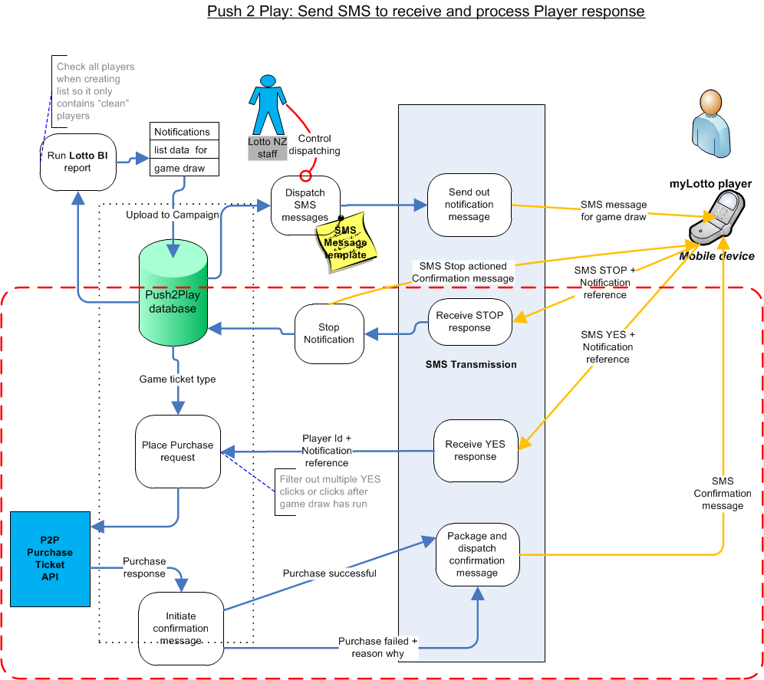

# Detailed Process Flow to proceed with ticket purchase

**Trigger:** a myLotto user has received an SMS notification message for the next Lotto draw. They type in a response that contains the word ‘yes’ (there may be different response formats such as YES, Yes, Yes thanks, etc) and then send this as a reply to the notification message.

**Process actions:**

SMS Transmission system receives the reply and routes it to a P2P system integration point (MULE)

The contents of the reply passed into the integration point are:

* Mobile phone number
* Character string indicating YES (possible values are: YES, yes, Yes, …etc)
* Metadata about the original message and the message reply. This metadata contains the original Notification message id and the id of the campaign that this notification was for.

The P2P system checks to see the latest campaign is still active for the received response:  
(Note: in the case when a user receives an SMS notification on Wednesday and does not respond YES to this notification until the next Saturday campaign is active, the user will be blocked from purchasing a ticket because their response contains an id for a previous closed campaign, so they will be treated similarly to YES responses that are too late for the latest campaign)

* If No, then this is a “too-late” purchase and the reason is “Request received for a previous closed draw”. The process will then jump down to the action below labelled “**Confirmation Message:**”
* If Yes then continue

The P2P system checks to see if it already has an instance of this reply in the P2P transaction table for the current pending draw:

* If Yes, then the reply can be ignored (do not send an SMS reply to save $)
* If No then continue

The P2P system locates the relevant record in the P2P campaign_entry table and updates the following columns:

* Sms_reply is set to YES
* Sms_replytime is set to the current date and the time that the P2P system received the reply

The P2P system checks to see if the reply has been received after the draw cutoff time which is always 7:30 PM on the draw day

* If Yes, then this is a failed purchase and the reason is “Request received after draw cutoff time”. The process will then jump down to the action below labelled “**Confirmation Message:**”
* If No then continue

The P2P system checks to see if the user has the LottoPB Game blocked  
(Note: this check will also be done by the ESi system)

* If Yes, then this is a failed purchase and the reason is “Lotto PB game is currently set to Blocked”. The process will then jump down to the action below labelled “**Confirmation Message:**”
* If No then continue

The P2P system checks if the user’s current spending limits (Weekly and Monthly) are exceeded  
(Note: this check will also be done by the ESi system)

Note: there is a time window between when the Notifications CSV file is created and the SMS Notifications are replied to. It is possible that within this time window, the myLotto user has purchased sufficient tickets to exceed either (or both) their Weekly and Monthly spending limits

* If Yes, then this is a failed purchase and the reason is “Spending limits are currently exceeded”. The process will then jump down to the action below labelled “**Confirmation Message:**”
* If No then continue

If none of the above checks fail then the P2P system will check the Player’s account balance  
(Note: this check will also be done by the ESi system)

* If the wallet balance is greater than $999, then the user is not permitted to purchase tickets, so this is a failed purchase and the reason is “Account balance exceeds $999”. The process will then jump down to the action below labelled “**Confirmation Message:**”
* If the user has insufficient funds in their wallet, then an an authorised credit card request is sent to DPS (Credit Card agency) for an account topup
* The topup amount is the larger of either a minimum of $4 [only applicable to P2P] or the difference between the wallet balance and the cost of the proposed purchase
* If the Topup request to DPS (Credit Card agency) is rejected, then this is a failed purchase and the reason is “Credit card problem”. The process will then jump down to the action below labelled “**Confirmation Message:**”
* If the request is accepted, the user’s wallet is credited by the topup amount and the process continues

The P2P system will assemble a purchase request to send to the ESi application:

* The mobile phone number is used to retrieve the user id and the purchase type (dip_type or favourite_name) from the opted_game table

The P2P system submits the purchase request to a Purchase Ticket API   
(P2P Detailed Design document section name = *API POST/provision/${optedgamesid}* ).  
Actions internal to the API are:

* If the Game Draw has closed for purchases then:
  + The purchase will not proceed
  + The API will return a failed response code (=result code) with an generic error message.
* Run a sequence of checks on the Player:
  + Check that the user is not changing their Email address
  + Check that the user does not have their Wallet suspended
  + Check that the user does not have their Account suspended
  + Check that the user does not have the Lotto Game currently blocked
  + Check that the user’s current spending limits (Weekly and Monthly) are not exceeded
  + Check that the user has sufficient funds in their wallet balance
* If any of the above checks fail, then:
  + The purchase will not proceed
  + The API will return a failed response code (=result code) with an associated error message explaining why.
* Tthe purchase request will now proceed and (assuming no system errors) tickets in the next Lotto Game will be purchased. The API will return:
  + A success response code (= result code)
  + The ticket numbers for the purchased ticket(s)
  + A total $ amount for the cost of the ticket(s) purchased

The P2P system will create a new instance of the purchase request in the P2P transactions table with:

* Opted game Id populated from the related entry in the P2P opted_game table
* Result code value (as described in the P2P Detailed Design document section identified above)
* Ticket Number value
  + If 2 or more tickets were purchased as a result of the request, then there are a matching number of entries in the transactions table
  + If the purchase request failed, then the online_ticket_number column in the transactions table is left null
* Purchase cost (the $ amount for the cost of each ticket purchased)
* A Draw Number sourced from the related entry in the P2P campaign entry table
* A Campaign Id sourced from the related entry in the P2P campaign table

**Confirmation Message**: The P2P system will then assemble an SMS message and pass it to the SMS Transmission system to send to the player.

The SMS message contents for a successful purchase are:

* Standard congratulations message body
* Advice to the player to check My Tickets in their myLotto account pages

The SMS message contents for a failed purchase are:

* Standard error message body
* Reason for failure (this will require the P2P system to retrieve the appropriate error message text from the ESI system using the purchase request result code)

# Detailed Process Flow to opt out of notification

**Trigger:** a myLotto player has received an SMS notification message for the next Lotto draw. They type in a response that contains the word ‘stop’ (there may be different response formats such as STOP, Stop, Stop please, etc) and then send this as a reply to the notification message.

**Process actions:**

SMS Transmission system receives the reply and routes it to a P2P system integration point (MULE)

The contents of the reply passed into the integration point are:

* Mobile phone number
* Character string indicating STOP (possible values are: STOP, stop, Stop, …etc)
* Metadata about the original message and the message reply

The P2P system will process a Stop response regardless of when it was received. However,

it will not check to see if it already has an instance of this reply in the P2P system [against the campaign_entry].

The P2P system locates the relevant record in the P2P campaign_entry table and updates the following columns:

* Sms_reply is set to STOP
* Sms_replytime is set to the current date and the time that the P2P system received the reply

In addition:

* Status of record in P2P system is set to ‘Deleted’
* P2P notification is deleted from the user’s Notification page in MyAccount
  + Confirmation message will be sent for a Stop request